
Measurement Investigation 2018

Name: ___________________

Validation
15 MINUTES
/ 12 marks

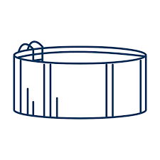
- The Smith family bought a swimming pool is in the shape of a cylinder as shown. The radius of the pool is 3 metres and the depth is 1.5 metres.

- Find the volume of this swimming pool to the nearest hundredth. [3marks]

- The Smith family decided to paint the outside of the pool green to blend in with the grass. What is the size of the area that needs to be painted? (to the nearest whole number) [3 marks]

- Unfortunately, after some severe weather the Smith’s family pool was destroyed. Before buying a new one they decided on purchasing a pool with a smaller volume for their back yard. The eldest son did some research into 2 pools with different dimensions. [6 marks]

Pool 1: radius = 3.5 m height = 1.71 m

Pool 2: radius = 2 m height= 3 m

Explain which option the Smith’s family should choose.

End of Validation

